Configuring Internal Route53 DNS (Nugget)

1)Launch 2 ec2 instances

2)Create a private hoted zone in the route53

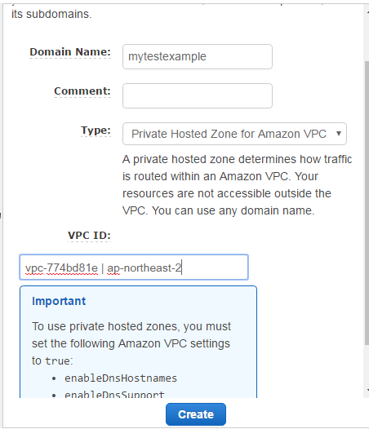

We see a message in the important section to set the following setting in the VPC. Go to the VPC section and select the VPC which you were using and click actions and set the things mentioned above as

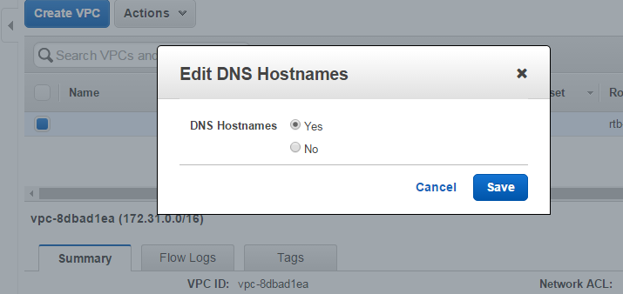

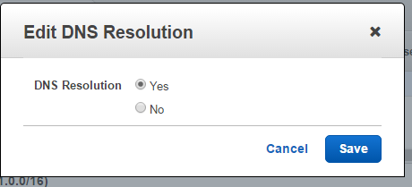

Now we need to assign name and resolution to our private addresses of the instances we created. So we have to create the record sets as

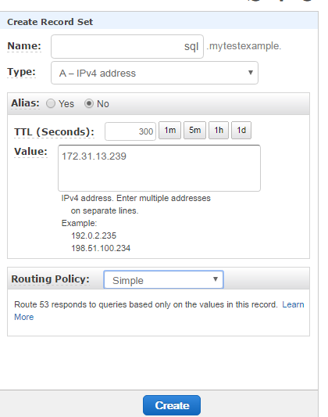

We gave the name as sql to this private ip.

For the second instance

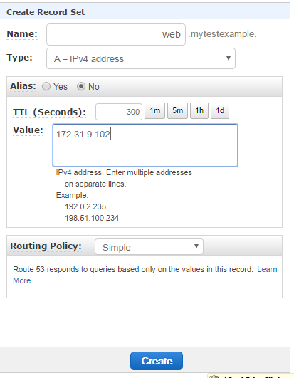

Now login to one of the instance as

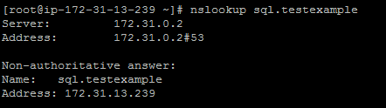





Make an entry of



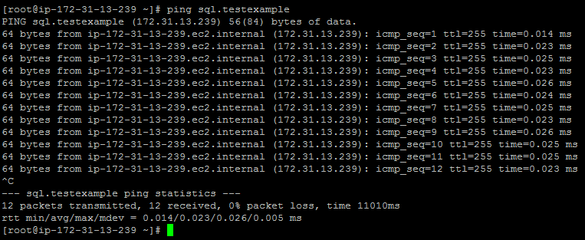

We can also do a ping sql only

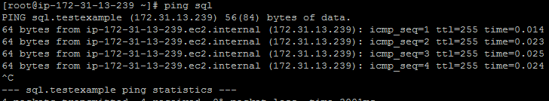

We were able to resolve the dns with just giving the ping sql because we made an entry in the /etc/resolve.conf. So even if don’t give ping sql.testexample and only give ping sql our linux machine will attach testexample while resolving it. So now we can just give hostname to connect to our machine inside of our environments.